Year 11 2022 Results Analysis Headlines
Pupils were included in the figures only if
- they completed their education on the school site until the start of their study leave in year 11(for 2019 and 2022) or being educated on the school site in March 2020 (for 2020).They were on pathway 1.
- they had an FFT estimate (those who did not take KS 2 SAT’s will not have been given a FFT estimate, but would have still been given a teacher target grade). Please see appendix 1 for an explanation of FFT estimates and how they are used at Archers Brook School.
English
Pupils were entered into both English Literature (taken at the end of year 10) and English Language exam, the highest grade was used in these calculations.
Maths
Pupils take this GCSE at the end of year 11
Science
Pupils took the combined science GCSE that has a value of 2 GCSE’s, this was used as a single result in these figures
ICT
The ICT examination is an online examination and can be taken at any point in key stage 4 when the pupil is ready to take it. As a level 1 qualification it is either a pass or fail (graded as equivalent to a high level GCSE grade 2). At level 2 it is also graded as a pass or fail (pass equivalent to a high 4 grade)
PSD
For the PSD award pupils have to complete all the course work which is externally assessed. This subject does not have an FFT estimate. This year no pupils were entered into the employability qualification as this is completed after a work experience.
Options/Other qualifications
These subjects had been chosen by the pupils and all have an element of coursework which is externally assessed and an external examination (Horticulture does not have an FFT estimate).
- These year 11 results are for the cohort of 12 pupils who were educated on pathway 1

External Examination Results 2022

This is the first year since 2019 that pupils have taken external examinations. In both 2020 and 2021 exam grades were determined by teacher assessed grades, checked against schools’ prior attainment data with teachers collating pupils work to demonstrate to the exam boards if required that the pupil was working at that grade (the school was not asked for any evidence).
In 2022 to mitigate against the effect that the restrictions due to Covid had on pupils’ education, the exam boards bought in measures that included prior knowledge of the exam topics as well as formula and equations sheets. This information was released to schools in February. This cohorts last year of uninterrupted education was when they were in year 8.
Broad Analysis of results
Due to how GCSE grades were achieved in 2020 and 2021 this year’s results will be compared to those in 2018 and 2019.
- There has been a very small decrease in the average number of GCSE gained from 9.6 in 2018 and 9.3 in 2020 to 9.2 in 2022, partially due to pupils’ choices of vocational subjects.
- There has been a decrease in the ABS points scored this year, this reflects the lower FFT expectations of this cohort. As the percentage of pupil’s achieving a threshold grade is broadly in line with other years. The exception to this is within the vocational qualifications. On closer analysis this has been identified in one curriculum area which has undergone significant changes. Monitoring of these changes have identified that the majority of current key stage 4 pupils will achieve the threshold in this curriculum area.
- Pupils continue to achieve overall higher grades in vocational qualifications (construction, sport, horticulture, PSD, home cooking and music) rather than GCSE’s with terminal examinations. (appendix 3). This continues the trend over the past 5 years proving that a vocational route, blended with the core subjects being taught as GCSE’s suits our learners. These vocational qualifications allow teachers to respond to the individual needs of our pupils, allows the celebration of success in small steps in subjects that the pupils are potentially choosing to continue with post 16.
- There is a corelation between pupil attendance in year 11 and achieving teacher target grades.

How were they achieved?

- Processes are embedded to ensure that teacher target grades in all subjects are both challenging and achievable. – triangulated with FFT estimate, previous pupil progress at Archers Brook School and teacher professional knowledge of pupil, checked by SLT,
(evidence can be found in subject outcome and assessment files).

- Continual analysis of pupil achievement against expected progress every half term with appropriate actions taken when needed, (evidence can be found in staff outcome and assessment files).
- Online GCSE revision tools for English and Maths (GCSE Pod) and Science (Tassomai) were being used by pupils in year 11, this was led by the subject leads for each subject
- After the year 11 mocks in December SLT met with subject leads to analyse their subject results to advice and support as necessary, this was also planned again in April after the second set of mocks.
- After analysis of previous year progress of pupils from key stage 3 to key stage 4 both the English and Maths key stage 3 curriculum was changed.

New Processes planned this year
- Whole school focus on improving literacy and attendance

- Staff training so that all know what a pupil needs to show to gain a GCSE grade 1 and a grade 4 (good pass) in English and Maths. These skills to be taught in all subject areas.

- Possibility of end of year exams in year 9 and 10, with pupil rewards for those pupils who achieve their target grades will be discussed.

- End of year exams at the end of year 10 with pupil rewards for those who reach their teacher target grades.

Appendix 1

Fisher Family Trust Aspire and ABS points

This is the new name for Fisher Family Trust, due to the changes of assessment at both key stage 2 and key stage 4, also the removal of national curriculum levels and the removal of end of key stage 3 teacher assessment levels.
The biggest change for Archers Brook School and the use of FFT is that due to the changes above, it no longer sets end of key stage 3 estimates in national curriculum levels but has replaced these with end of key stage 4 estimates based upon end of key stage 2 (year 6) SAT’s levels in English and Maths.
It does though allow these end of key stage 4 levels be expressed as either grades or numbers and change the level of challenge for individual pupils.
It can also show attainment 8 and progress 8 dashboards to show pupil progress using this measure.
They are planning in the future to set up a proof of progress system by having end of year tests for pupils in years 7 to 10 in English and Maths and use this information held in student explorer which also records attendance, school moves and Free School Meals to benchmark pupils nationally.
However the Fisher Family Trust will only record and use whether a pupil has an EHCP and a small number of ‘at risk factors’ (e.g. number of moves between key stages) it does not take into account pupils who have multiple complex needs as the majority of our pupils have, also approximately half of pupils with an EHCP in CWAC have needs that can be met within a mainstream school, where as our pupils require additional support to access an education. For this reason, we state that the threshold of success for our pupils will be within 1 grade of the FFT estimate.
Therefore, it becomes even more important for us to quickly and accurately assess our pupils on entry to the school and use any prior information and the target setting capability of FFT to set aspirational and challenging end of year and end of key stage targets for our pupils. We then assess the pupils at the end of every half term and assess this against their end of year target, record this evidence of the stage of progress in our assessment and outcomes files and use the drill down sheets at the end of every term to ensure that we continually improve outcomes for the pupils.
Attached is a copy of how the new grades (1 – 9) at GCSE compare with the current GCSE grades (A* G). The only grade equivalent for the first year is that a 4 will be the equivalent of a grade C.
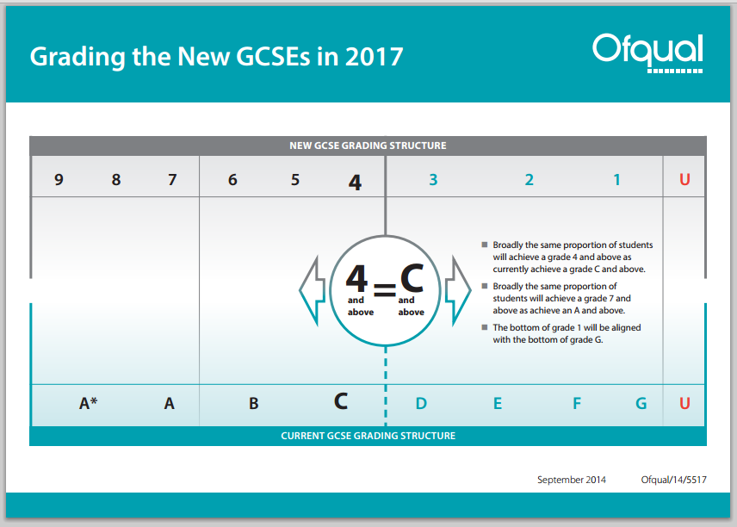
#

Appendix 2
Pathways through our curriculum
Pathways through our curriculum are supported through a range of assessments
We currently offer two distinct pathways through from KS2 with all pupils accessing our Wellbeing Curriculum regardless of academic pathway.
Pathway One
The Pathway One curriculum has been designed for learners who are working towards Entry level qualifications at KS4. This group of pupils will be working below ARE (age related expectations) in most, if not all, areas of the curriculum. This cohort is few in number in our setting, the overwhelming majority of our pupils being level 2 learners at KS4.
Formal communication is embedded in the learning although pupils still need time to process their learning and record/use communication purposefully; these pupils may need learning facilitated via higher levels of scaffolding and augmented forms of communication to promote independence. These pupils will likely have specific barriers to learning that impact on their ability to access the National Curriculum and will access specific teaching and interventions to overcome this.
At KS4 these pupils will have a well-designed transition and a supported post 16 pathway.
Pathway Two
The Pathway Two curriculum has been designed for learners who are working towards level 2 or 1 qualifications at KS4. This group of pupils will predominately be working at ARE in most areas of the curriculum.
Pupils within this Pathway may have specific barriers to learning that impact on their ability to access the National Curriculum, but will access specific teaching and interventions where needed to support them in attaining skills to overcome this. These pupils may benefit from scaffolded learning, yet are mostly independent in their access of learning and will benefit from High Quality Specialist subject teaching in order to attain to their best outcome.
At KS4 these pupils will have a clear Post 16 pathway to education and/or employment at level 2 or above.
Pathway 3
This pathway has been designed for pupils that experience difficulties accessing the first 2 pathways. They have a designed bespoke curriculum, which contains as a minimum literacy and numeracy, but can also include a tutor for other subjects, college courses, work experience/motivation placements etc. This pathway does not preclude them from attending lessons at Archers Brook School or any other services.

Our curriculum is designed to be flexible so that pupils may move between pathways and access courses on other pathways.

Archers Brook School External Qualification – Points Equivalents

GCSE Grade | ABS Points
9 | 70
8 | 64
7 | 58
6 | 52
5 | 46
4 | 40
3 | 34
2 | 28
1 | 18

Vocational Qualifications
 | Award  (0.5 GCSE) | Certificate  (1 GCSE) | Extended Certificate  (2 GCES’s) | Diploma  (3GCSE’s)
Level 2 |  | Distinction 55
Merit
49
 | Pass  25 | Pass  46 | Pass  96 | Pass  184
Level 1 | Pass  12 | Pass  25 | Pass  60 | Pass  100

Entry Level Certificate
Grade 3 | 14
Grade 2 | 10
Grade 1 | 6

Appendix 2
Average Point Score (2019) per pupil of the 12 pupils on pathway 2 educated full time on the school site compared with the same cohort in previous years.

Average number of GCSE’s gained (or equivalent) of the 12 pupils on pathway 2 educated full time on the school site compared with the same cohort in previous years.

Appendix 3
Exceeded FFT estimate
Matched FFT estimate
Not matched FFT estimate by one grade but have met ABS threshold
Not matched FFT estimate by 2 or more grades

English
FFT D/3 or above | From 8 pupil results  2018 | From 9 pupil results 2019 | From 7  pupil results  2020 | From 3 pupil results  2021 | From  8  pupil results  2022 | FFT E/2 or below | From 4 pupil results  2018 | From 3  pupil results  2019 | From 3 pupil results  2020 | From 4  pupil results  2021 | From 4  pupil results  2022
 |  |  | 14% |  |  |  | 25%
 |  | 22% | 28% | 33% | 13% |  | 75% | 33% | 33% | 50% | 25%
 | 63% | 22% |  | 33% | 37% |  |  | 66% | 33% | 25% | 50%
 | 37% | 56% | 57% | 33% | 50% |  |  |  | 33% | 25% | 25%

Therefore 75% are at or above threshold 2018
Therefore 58% are at or above threshold 2019
Therefore 50% are at or above threshold 2020
Therefore 72% are at or above threshold 2021
Therefore 58% are at or above threshold 2022
Maths
FFT D/3 or above | From 8 pupil results  2018 | From 9 pupil results 2019 | From 7  pupil results  2020 | From 3 pupil results  2021 | From  5  pupil results  2022 | FFT E/2 or below | From 4 pupil results  2018 | From 3  pupil results  2019 | From 3 pupil results  2020 | From 4  pupil results  2021 | From 7  pupil results  2022
 |  |  | 20% |  |  |  | 25% | 33%
 |  | 11% |  | 33% | 20% |  | 75% |  | 40% | 50% | 14%
 | 37% | 45% | 60% |  | 40% |  |  | 33% | 60% | 25% | 43%
 | 63% | 45% | 20% | 66% | 40% |  |  | 33% |  | 25% | 43%

Therefore 58% are at or above threshold 2018
Therefore 58% are at or above threshold 2019
Therefore 90% are at or above threshold 2020
Therefore 68% are at or above threshold 2021
Therefore 58% are at or above threshold 2021

Science
FFT D/3 or above | From 6 pupil results  2018 | From 9 pupil results 2019 | From 7 pupil results 2020 | From 7 pupil results 2021 | From 8  pupil results 2022 | FFT E/2 or below | From 7 pupil results  2018 | From 3  pupil results 2019 | From  3  pupil results 2020 | From  3  pupil results 2022 | From  4  pupil results 2022
 |  |  | 28% |  |  |  | 14% | 66%
 | 67% | 55% | 43% | 50% | 25% |  | 86% | 33% | 33% | 60% | 50%
 | 16% | 22% | 28% | 50% | 62% |  |  |  | 66% |  | 50%
 | 16% | 22% |  |  | 13% |  |  |  |  | 40%

Therefore 92% are at or above threshold 2018
Therefore 83% are at or above threshold 2019
Therefore 100% are at or above threshold 2020
Therefore 72% are at or above threshold 2021
Therefore 75% are at or above threshold 2022

ICT
FFT D/3 or above | From 5 pupil results  2018 | From 7 pupil results 2019 | From 5 pupil results 2020 | From 2 pupil results 2021 | From 4 pupil results 2022 | FFT E/2 or below | From 7 pupil results  2018 | From 3 pupil results  2019 | From 5 pupil results 2020 | From 5 pupil results 2021 | From 8 pupil results 2022
 | 40% | 14% |  |  | 100% |  |  | 40%
 | 40% | 86% | 80% | 100% |  |  | 100% | 60% | 80% | 80% | 75%
 | 20% |  | 20% |  |  |  |  |  |  | 20%
 |  |  |  |  |  |  |  |  | 20% |  | 25%

Therefore 100% are at or above threshold 2018
Therefore 100% are at or above threshold 2019
Therefore 90% are at or above threshold 2020
Therefore 100% are at or above threshold 2021
Therefore 92% are at or above threshold 2022

All other subjects that can be assessed using an FFT estimate
FFT D/3 or above | Results  2018 | From 27 pupil results 2019 | From 10 pupil results 2020 | From 10 pupil results 2021 | From 19 pupil results 2022 |  | FFT E/2 or below | Results  2018 | From 8 pupil results 2019 | From 7 pupil results 2020 | From  5  pupil results 2020 | From  9  pupil results 2022
 | 68% | 30% | 40% |  | 48% |  |  |  | 13% | 57% |  | 100%
 | 26% | 26% | 30% | 100% | 16% |  |  | 75% | 26% | 43% | 80%
 | 6% | 30% | 20% |  | 10% |  |  | 25% | 62% |  | 20%
 |  | 14% |  |  | 26%

Therefore 100% are at or above threshold 2018
Therefore 92% are at or above threshold 2019
Therefore 100% are at or above threshold 2020
Therefore 100% are at or above threshold 2021
Therefore 82% are at or above threshold 2022

